12th September 2016

**LANGEVELD LEADS SEAT LEON EUROCUP AFTER AUSTRIA**

The SEAT LEON Eurocup, which has Japanese premium Tyre manufacturer YOKOHAMA as exclusive tyre supplier, visited the Red Bull Ring in Austria at the weekend, offering plenty of action and changes at the top. The Dutch driver Niels Langeveld managed to recover the championship lead after a solid performance in Race 1. Although Langenveld did not cross the chequered flag first, he took benefit from a Race Direction decision to penalise Mikel Azcona who had dominated from the start. Azkona had exceeded the track limits and was given a 3-second penalty which allowed the Dutchman Niels Langeveld to take the victory.

Mikel Azcona had to settle for second and Alex Morgan, who had started on pole, in third place. For his part the Norwegian Stian Paulsen who had been leading the Championship did not enjoy his most successful weekend at the Ring and managed only some points with a fourth place in the second race.

Race 2 was also very competitive, due to the inverted grid. The Frenchman Julien Briche was soon in the lead whilst two hot favourites Morgan and Azcona made ground with their steady pace and recovering positions well. The pace of both drivers catapulted them to the podium at the end of the spectacular racing with Azcona second and Morgan third, both following Julien Briche.

After the two races in Austria, Langeveld leads the table again with 171 points, Stian Paulsen closely follows with 163 and Mikel Azcona now within reach of both leaders in third with 155. The SEAT León Eurocup is back next week at the Nürburgring, in Germany.

**Standings. SEAT LEON Eurocup 2016**

1. Niels Langeveld 171 points

2. Stian Paulsen 163 points

3. Mikel Azcona 155 points

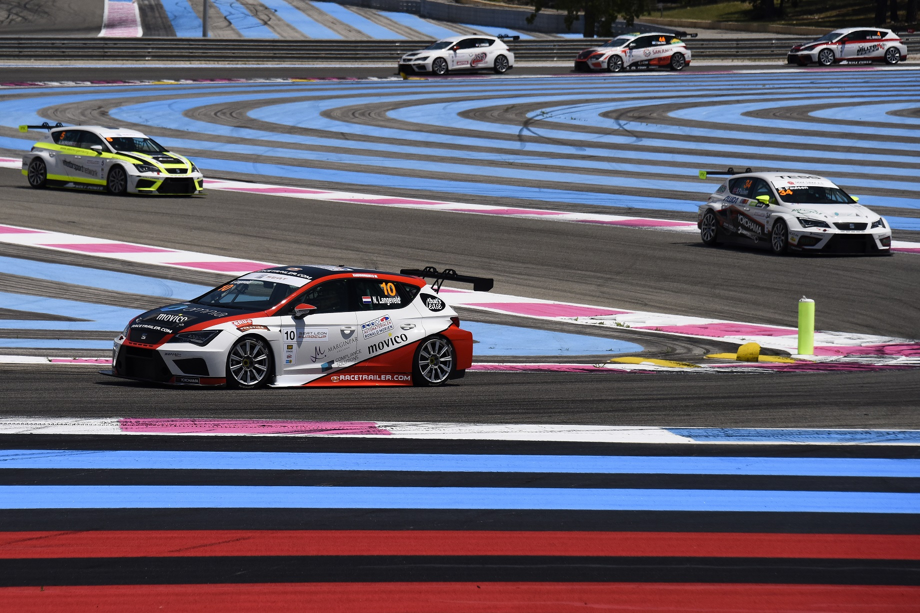

Flying Dutchman Leads International Series